
PAPATOETOE & DISTRICT RSA (Inc)
NEWSLETTER
JULY 2 0 2 4
Papatoetoe & District RSA office@papatoetoersa.org.nz
22 Wallace Road. Papatoetoe, Auckland 2025. prsapapatoetoe@gmail.com
PH: (09) 278 6372.






WELFARE

Stephen Walker is our new Welfare Officer, for those requiring assistance or have any enquiries, please contact the office on 09 278 6372

MONTHLY NEWSLETTERS
Members wishing to receive newsletters and updates via email, please email the office.
We have a Facebook page too to keep updated.
Check it out!

RSA NOTICES

THURSDAY & SATURDAY MEMBERSHIP DRAWS
The draws will be conducted by the Duty Officer and be drawn between 6 – 7.30 pm. The draw starts at $200.00 and increases by $25.00 each Thursday and Saturday night to a maximum of $1,000.00.

THURSDAY NIGHT LUCKY STRIKE
This will be run dependent upon there being enough people in the club. Patrons are asked to purchase tickets at $1.00 each. When the draw takes place, 80% of ticket money collected goes to the winner and 20% goes back to the RSA. You must be here to win.

LOST/STOLEN MEMBERSHIP CARDS
Replacement cards cost $5.00. Members who have lost or have had their membership card stolen can get another card.

SAFETY ISSUES
Members are asked NOT to open the EXIT rear doors for non-members to come into the RSA please.

MEDICAL RECEIPTS
Members eligible for medical reimbursements are advised your payment is paid directly into your bank account. No exemptions.

Note: Medical receipts will be processed as soon as possible. Your patience on this matter is appreciated.

 LAST POST

- Erica GOW 16 June 2024
- Lincoln HOPKINS 21 June 2024
- Alan FRY 01 July 2024

We will remember them.

WELCOME NEW MEMBERS TO OUR CLUB

From 1st June to 31st June 2024

- Sujay NAND
- Talei WILLIAMS
- Marie MANUO
- Sarah-Jane BEACH

WELFARE VAN

Members requiring the Welfare van are asked to contact the RSA Office – not the driver.
Phone 09 278 6372
Persons using the service are asked to contribute a minimum $5.00 donation.
Thank you.

HANDLE CLUB

Friday at 6.30pm.

Join the Handle Club for $10.00 a year.
The year ends 31 December.

Be in the weekly draw for 5 free handles.

For financial members of this RSA only.

8-BALL CLUB NIGHT

Thursdays at 7.30pm
National Rules
All Welcome
SOCIAL “HOUR”

Thursday and Saturday
from 5.30pm to 7pm.

JOKER’S WILD
Now drawn Saturday night after the membership draw.
Can be purchased during the week.
See the Bar Staff.

JAM SESSIONS
First Friday of the month,
next one is Friday 5th of July,
from 7.30pm
ALL SINGERS AND MUSICIANS WELCOME

HOUSIE

* Every Thursday evening at 7pm.

* Every Friday evening at 6.45pm.

EVERYONE WELCOME


WOMEN’S SECTION
Thank you to those who donated items and supported our Garage Sale on 15 June. A special thank you also to Denise Bennett for her assistance.

Our monthly member meeting for July is scheduled for Wednesday 10 July at 10.30 am. We have a guest from Age Concern, who will talk on the facts about slips, trips and falls and their likely causes and provide information on easy strategies to reduce the risk of falling, which will help to maintain independence.

Anyone interested in joining the Women’s Section can pick up a form from the office, or can contact me for more information.

Diana Raututi
President/Secretary
021 127 2486

WELFARE
First of all, thank you to those who showed their interest and electing me as Welfare Officer / Support Advisor for our wonderful RSA / Club.
It has been remiss of me not communicating to you all sooner but hope to write a regular Report each month on the progress and work carried out by Welfare. These Reports will also be submitted to the Executive Committee.
I have done some “work” behind the scenes. Part of this work was a submission to the Executive Committee of around 25 suggestions, ideas and thoughts I have compiled. I am awaiting confirmation of this submission and do not expect them all to be approved or be in my favour. However, I hope the majority will be.
One of the submissions was that to enable our Welfare to continue, I would ideally like request some able-bodied personnel to assist where and when necessary. You MUST have a car, a mobile phone, an email address and have a Papatoetoe RSA shirt or blouse for identification purposes. Please give your name and phone number with the Office staff. In fact, anything involving Welfare should be submitted to the Office first. I am hoping to have a separate “Welfare” email address so this will lessen the work for the Secretary Manager and Office Manager.
As you are probably aware, I will not be in New Zealand from 15 August for a while and therefore no Monthly Reports will be given. Hopefully I will have internet where I am going, so I still will be able to keep in touch.

Kind regards

Stephen L. Walker
Welfare Officer / Support Advisor

Meat Raffles
Thursday Night’s
($2.00 a Ticket)
From 5pm

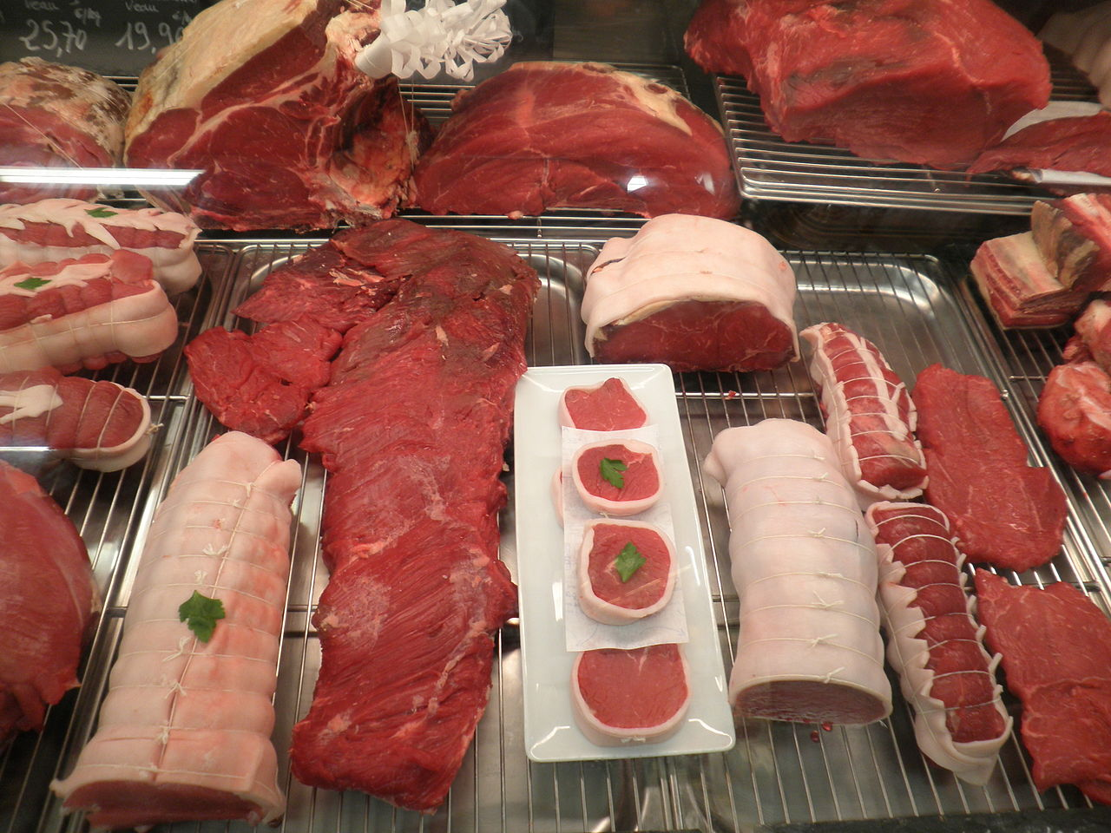
INDOOR BOWLS SECTION

We meet every Wednesday at 12pm. If you would like to give it a go.
Come and join us.

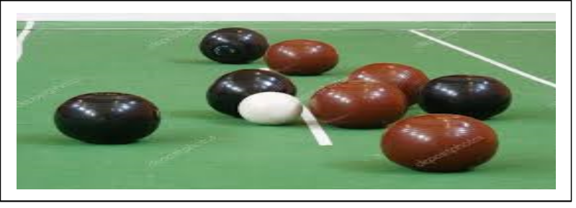
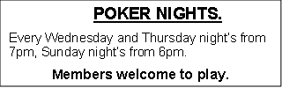
SATURDAY LOTTO BONUS TICKETS

Your chance to win $50.00 should you have the Saturday Lotto Bonus number.
Tickets available from the bar.
Two Draws. $2.00 a ticket.
Good luck!!!

The Great Outdoors
A young man wanted to invite his girlfriend to their farm but was embarrassed by the old-fashioned outdoor outhouse.
He kept bickering with his dad about getting a modern one with indoor plumbing, but the old-timer didn't want to give in.
Out of sheer desperation, he slips out one night, and with a huge shove - pushes the entire outhouse down the hill. The solid affair was still intact when it reached the bottom, but he knew it would be too damaged to drag back up with the truck's winch.
The next morning at breakfast, his father asks him if it was he who destroyed the outhouse, and at the same time, reminds him of the story of George Washington and the cherry tree.
"Yes, Dad," sighed the boy. "It was me."
"I'm glad you're so honest." said his father.
"And as punishment, you have to start digging the pit for a new one immediately."
"But Dad," protests the boy, "when George Washington admitted it was he who cut the tree, his father didn't punish him!"
"Yes, you're right," said his father. "But George's dad wasn't in the cherry tree when he cut it down!"


RESTAURANT
HOURS

Lunch:

Thursday and Friday
12 noon – 2 pm

Dinner:

Thursday to Saturday
6 pm – 8 pm

Ask us about your next function today.
We can cater for most events or functions.

Conditions apply.

BAR & GAMING MACHINE HOURS

Monday | CLOSED:  Reserved for Venue bookings, Group bookings and special occasions
Tuesday | 2 pm up to 12.00 am
Wednesday | 12 pm up to 12.00 am
Thursday | 12 pm up to 12.00 am
Friday | 12 pm up to 12.00 am
Saturday | 2 pm up to 12.00 am
Sunday | 3 pm up to 10.00 pm
N.B. Hours for the bar and gaming machines
may vary without notice. Closing times are
flexible and vary according to patronage.

We look forward to seeing you all soon.
Don’t forget to renew your membership, or surprise someone with their own membership for Christmas.

