
PAPATOETOE & DISTRICT RSA (Inc)
NEWSLETTER
OCTOBER 2024
Papatoetoe & District RSA office@papatoetoersa.org.nz
22 Wallace Road. Papatoetoe, Auckland 2025. prsapapatoetoe@gmail.com
PH: (09) 278 6372.



YOUR RSA



NEEDS YOU

Show your support by
Bringing in your family and friends

What would you like to be involved in within your RSA.
Email us your suggestions.

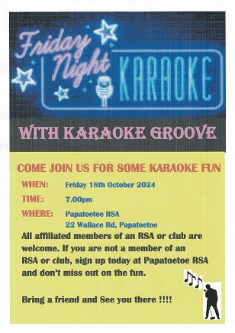

JAM SESSIONS
First Friday of the month,
next one is Friday 4th of October,
from 7.30pm
ALL SINGERS AND MUSICIANS WELCOME

 LAST POST
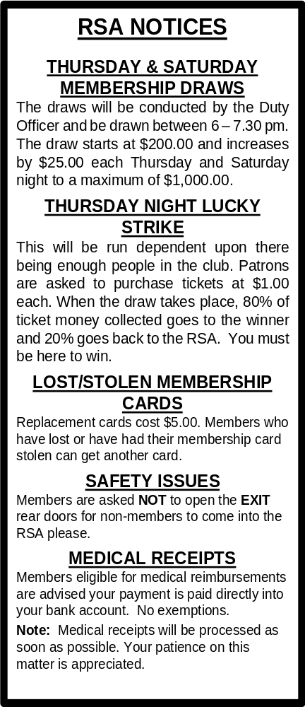

- Robert WIREPA 4 September 2024

We will remember them.

WELCOME NEW MEMBERS TO OUR CLUB

From 1st September to 31st September 2024

1. David SEGI
2. Robert WILSON
3. Matthew PARKER
4. Touariki DODDS
5. Gail HOHAIA

WELFARE VAN

Members requiring the Welfare van are asked to contact the RSA Office.
Phone 09 278 6372
Persons using the service are asked to contribute a minimum $5.00 donation.
Thank you.

HANDLE CLUB

Friday at 6.30pm.

Join the Handle Club for $10.00 a year.
The year ends 31 December.

Be in the weekly draw for 5 free handles.

For financial members of this RSA only.

8-BALL CLUB NIGHT

Thursdays at 7.30pm
National Rules
All Welcome
HOUSIE

* Every Thursday evening at 7pm.

* Every Friday evening at 6.45pm.

EVERYONE WELCOME
SOCIAL “HOUR”

Thursday and Saturday
from 5.30pm to 7pm.

JOKER’S WILD

Now drawn Saturday night after the membership draw.
Can be purchased during the week.
See the Bar Staff.
MONTHLY NEWSLETTERS
Members wishing to receive newsletters and updates via email, please email the office.
We have a Facebook page too to keep updated.
Check it out!

WELFARE
Due to me being on vacation, there will probably be no Welfare Report until December. In the meantime, please stay safe and keep well.
Kind regards,
Stephen L. Walker,
Welfare Officer / Support Advisor.

WOMEN’S SECTION

Papatoetoe RSA Womens Section will be hosting the Auckland District RSA Womens’ Sections AGM in our RSA on Monday 7 October.

Our monthly meeting for October is scheduled for Wednesday 9 October. Doors open at 10 am. Meeting starts at 10.30. We will be having a few games of Housie and sharing some friendship. Don’t forget our usual Trading Table to bring and buy.

Our next Garage Sale is planned for Saturday 9 November at 9 am. Donations for the Garage Sale can be accepted the week prior. Only clean, serviceable clothing to be donated please.

Anyone wishing to join the Women’s Section can pick up an application form from the Office. Cost is $5.00 per annum.

Diana Raututi
President/Secretary
021 127 2486

SATURDAY LOTTO BONUS TICKETS

Your chance to win $50.00 should you have the Saturday Lotto Bonus number.
Tickets available from the bar.
Two Draws. $2.00 a ticket.
Good luck!!!

INDOOR BOWLS SECTION

We meet every Wednesday at 12pm.
If you would like to give it a go.
Come and join us.

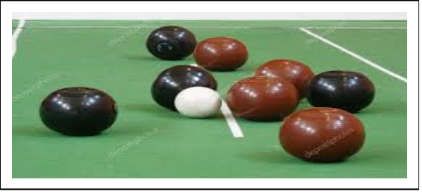
Baton’s up Results
Winning Numbers were:
- 21. 51. 73.
7. 24. 53. 82.
13. 37. 65. 92.
20. 48. 66. 97.
Congratulations to all winners and thank you to all that supported the 8’Ball Section fundraiser

https://jokesfunnystories.quora.com/The-three-grandmas-and-the-old-grandpa
The Great Outdoors

An old-fashioned lady wrote a letter to a campground to ask about the facilities before booking a camping spot. She didn't quite know how to ask if there were bathrooms on-site or if they had to use the ones in their RV, nor could she bring herself to write the word "toilet" in her letter. After much deliberation, she wrote down bathroom commode, then thought she was still being too direct for a polite letter, so she simply wrote, "Does the campground have its own BC?"
The campground owner simply couldn't figure out what the woman was talking about. The BC reference really stumped him. Hoping someone else would know, he showed the letter to several campers, but they were just as confused, although one woman commented that she might be referring to the Baptist Church just up the road since it was holding a number of summer activities. Since that was his only lead, he sat down and wrote the following reply:
Dear Madam
I am pleased to inform you that a BC is located nine miles north of the campground and is capable of seating 250 people at one time. I admit it is quite a distance away, if you are in the habit of going regularly, but no doubt you will be pleased to know that a great number of people take their lunches along and make a day of it. They usually arrive early and stay late. It's such a beautiful facility, and the acoustics are marvelous. Even the normal delivery sounds can be heard. The last time my wife and I went, it was so crowded we had to stand up the whole time we were there. It may interest you to know that a supper is planned to raise money to buy more seats. If you do decide to come down to our campground, there are a few people here who would be delighted to go with you the first time, sit with you, and introduce you to all the other folks. Remember, this is a friendly community.
Sincerely,
(Campground Owner)



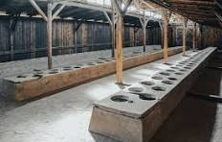
RESTAURANT
HOURS

Lunch:

Thursday and Friday
12 noon – 2 pm.

Dinner:

Thursday to Saturday
6 pm – 8 pm.

Ask us about your next function today.
We can cater for most events or functions.

Conditions apply.

BAR & GAMING MACHINE HOURS

Monday | CLOSED:  Reserved for Venue bookings, Group bookings and special occasions
Tuesday | 2 pm up to 12.00 am
Wednesday | 12 pm up to 12.00 am
Thursday | 12 pm up to 12.00 am
Friday | 12 pm up to 12.00 am
Saturday | 2 pm up to 12.00 am
Sunday | 3 pm up to 10.00 pm
N.B. Hours for the bar and gaming machines
may vary without notice. Closing times are
flexible and vary according to patronage.

We look forward to seeing you all soon.
Don’t forget to renew your membership, or surprise someone with their own membership for Christmas.

